

File Handling in SV
By: Eng. Islam Hamdy Mohamed
Guided By: Eng. Hassan Khaled

- Snippets for the implemented code
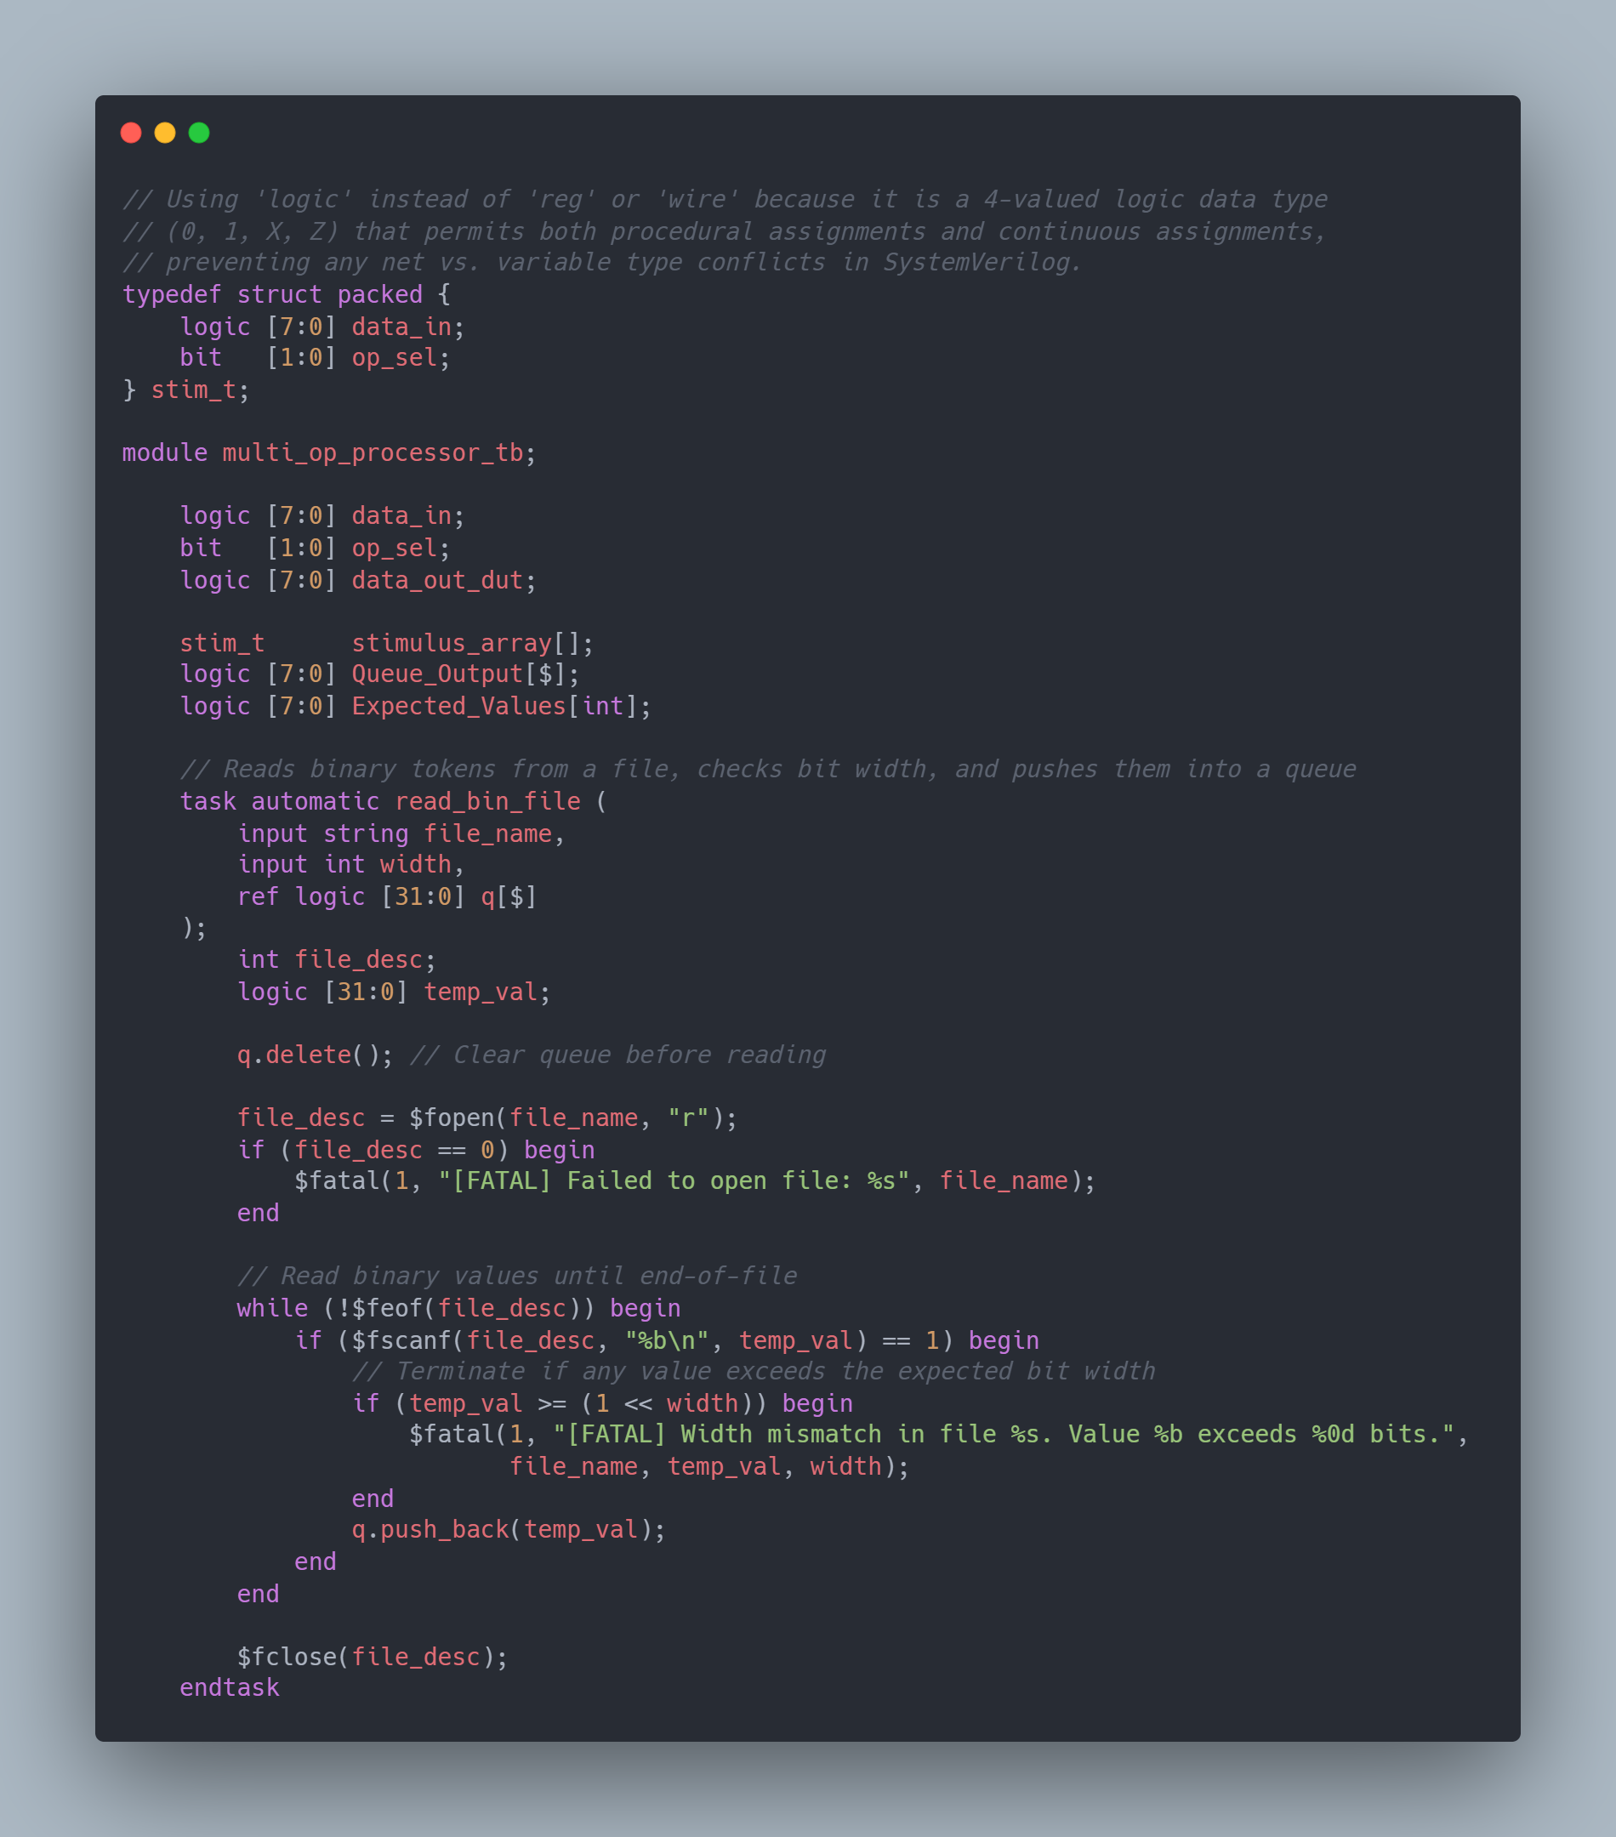

Figure 1 Declaration of Functions and Tasks {1}
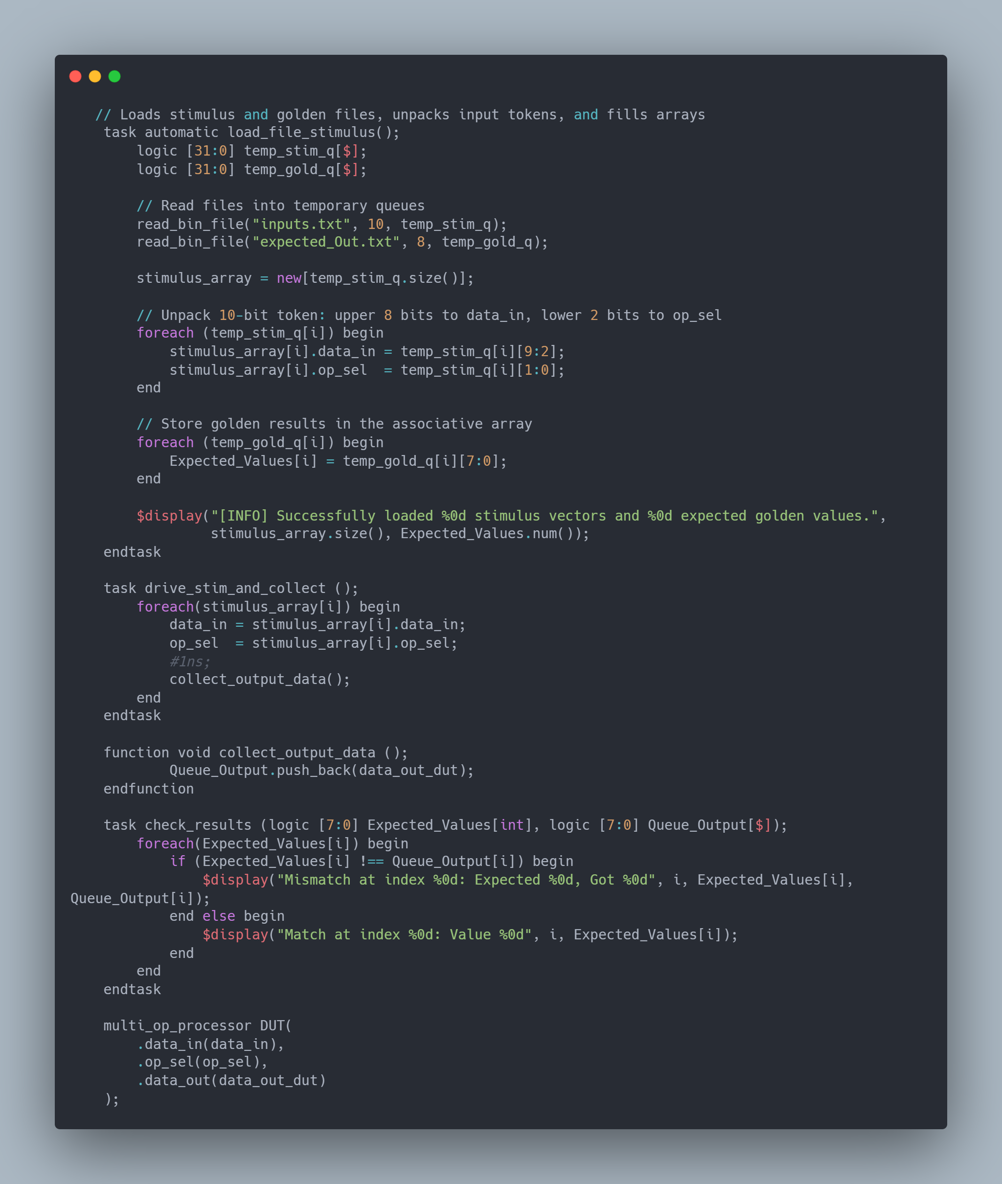
Figure 2 Figure 1 Declaration of Functions and Tasks {2}
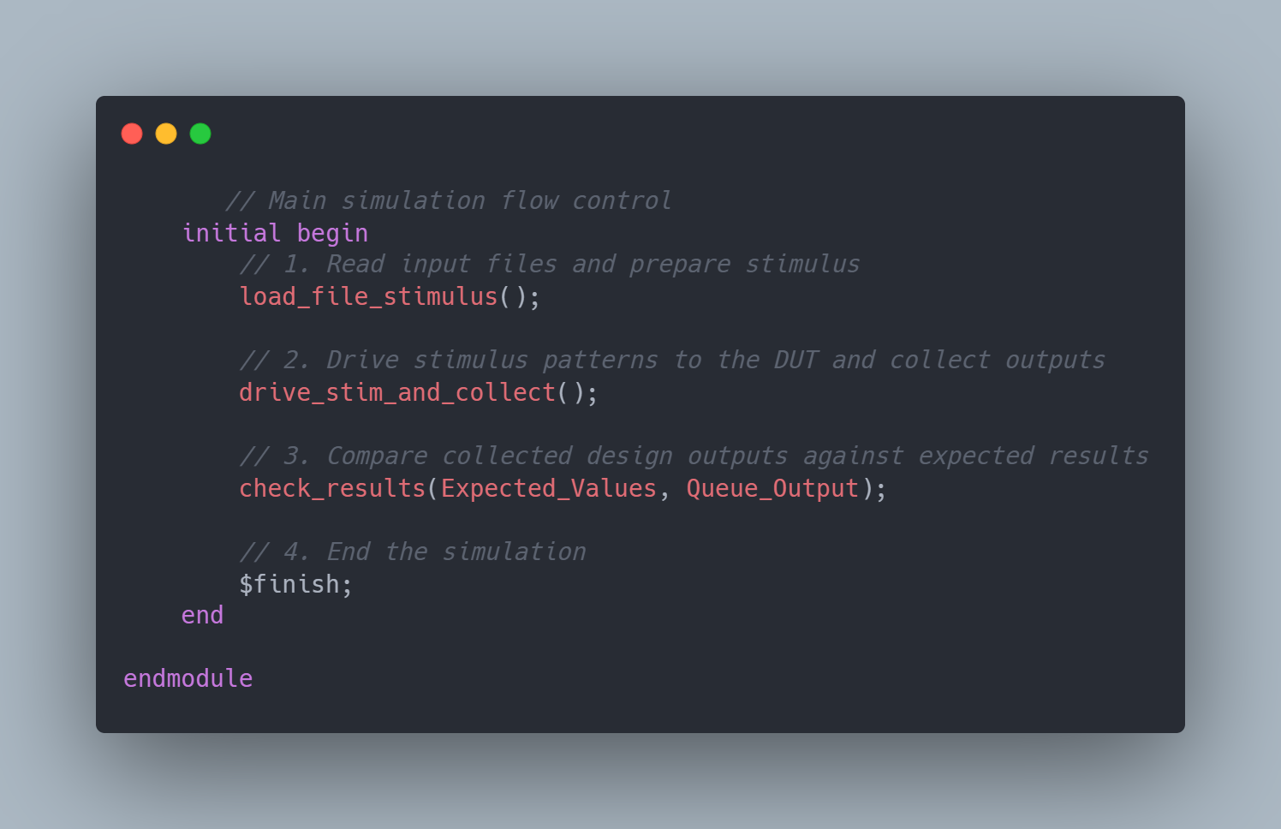

Figure 3 Initial Block (Main Code)

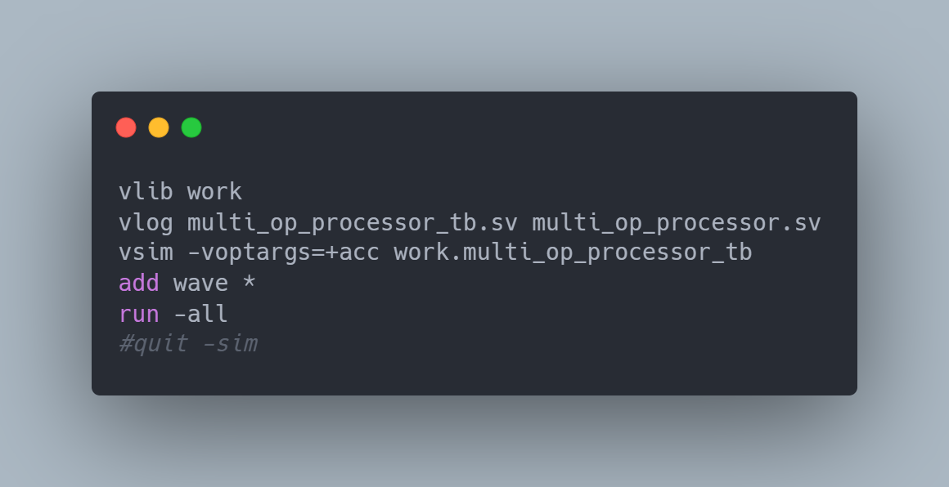

Figure 4 Do file code for automating the process.

- Snippet for the waveform shows the values for created variables
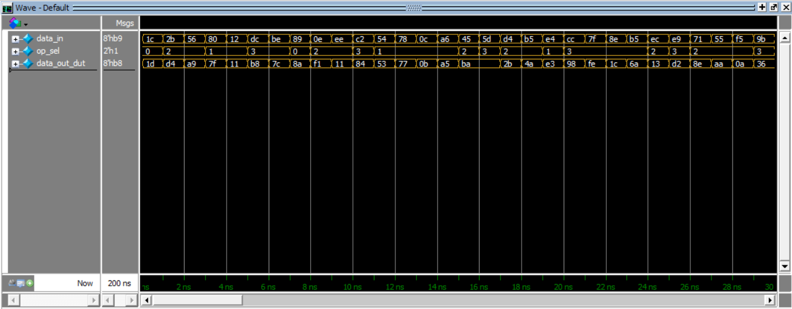
Figure 4 Waveform shows the created variables

Figure 5 waveform shows the values for created variables

- Snippets for the logs show the all printed values.

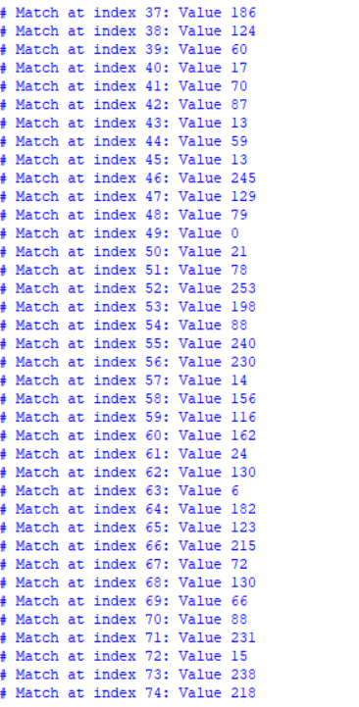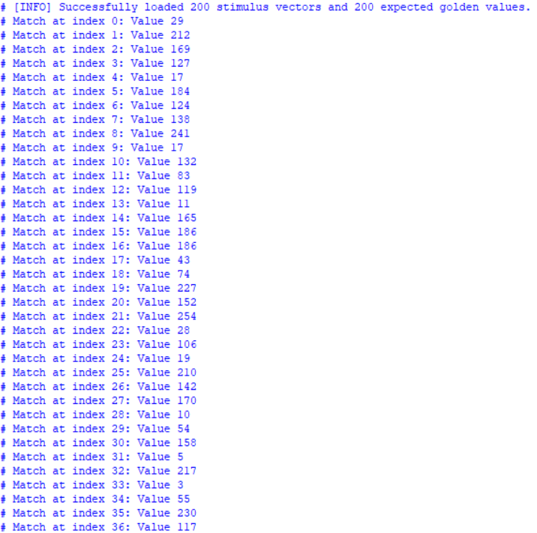

Figure 6 LOG {1}
Figure 7 LOG {2}

